Name _______________________________________________ ES Unit 8 Sheet: Ecology & Biodiversity

Students will answer all vocabulary, study guide questions and additional study problems as outlined below. Supplemental and Reading Material provide additional information to help master concepts.

Essential Standards: | Students Will Be Able To:
1.1.4 Explain how incoming solar radiation makes life possible on Earth.  2.7.1 Explain how abiotic and biotic factors interact to create biomes.  2.7.2 Explain why biodiversity is important to the biosphere.  2.7.3 Explain how human activities impact the biosphere.  2.8.3 Explain the effects of uncontrolled population growth on Earth’s resources. | - Explain how solar energy is transformed into chemical energy through photosynthesis.  - Explain how biotic and abiotic factors determine biome classification.  - Explain biodiversity and compare impacts of biotic and abiotic factors on biodiversity.  - Match soils to biomes & infer relationships between the environment and organisms living in the biome.  - Explain the impact of a loss of biodiversity.  - Explain the effects of human population growth on the plant and animal species of North Carolina.  - Explain the effects of invasive species on terrestrial and aquatic ecosystems.  - Summarize ways to mitigate human impact on the biosphere.  - Explain carrying capacity and infer limiting factors to human population growth (globally and NC specific).

Vocabulary—Define, know, and be able to apply the following terms:

- Photosynthesis*
- Cellular Respiration
- Biotic*
- Abiotic*
- Biome
- Ecosystem*
- Biodiversity*
- Genetic Variation*
- Population *
- Habitat*
- Invasive Species*
- Overharvesting*
- Carrying Capacity*
- Limiting Factors
- Exponential Growth

Academic students complete vocabulary with asterisks *only. Honors students complete all 20 words.

Study Guide—Answer, know, and understand the following concepts:
- Identify which biome(s) fit the following description:

  - Hottest year-round
  - Coldest year-round
  - Highest annual precipitation
  - Lowest annual precipitation
  - Distinct wet and dry seasons
  - Poorest soil quality
  - Best soil for quality
  - Mid-west United States
  - Highest biodiversity
  - Plants with water-storage adaptations
  - Animals with heat-retention adaptations
  - Mainly coniferous trees

- Explain the processes of photosynthesis and cellular respiration.
- Describe the impact of specific biotic and abiotic factors on the rate of photosynthesis.
- Give several examples of abiotic factors affecting biotic factors of an environment.
- Differentiate between species, population, and community.
- Explain the importance of genetic diversity within a species.
- Explain the importance of species biodiversity within an ecosystem.
- Draw a population curve and label: carrying capacity, exponential growth, logistic growth, biotic potential.
- List several factors that can impact the size of a population. Indicate if each is natural, man-made, or both.
- Identify several impacts of a growing population on natural resources.
- Identify general methods of introduction of invasive species.
- Explain why invasive species pose a threat to their non-native ecosystem.
- Identify 3 invasive species that are a problem in North Carolina AND describe their impacts.

Supplemental--Do practice the following activities as you work through the unit:
- Create a chart that includes general climate, soil, plants, and animals for each of the following biomes: tundra, taiga, temperate deciduous forest, tropical rain forest, hot desert, grassland, and savanna.

Unit Reading Material:

- Digital Textbook: Ch. 5.6, Ch. 8.1-8.8
- Class Notes
- Handouts

Additional Study Problems:
- Fill in the following table:

BIOME | CLIMATE | SOIL | PLANTS | ANIMALS
TUNDRA
TAIGA
TEMPERATE DECIDUOUS FOREST
TROPICAL RAIN FOREST
HOT DESERT
GRASSLAND
SAVANNA

- Write the chemical equations for photosynthesis & cellular respiration (label each).

- Write the order of all ecosystem components from smallest (organism) to largest (biosphere).

- Based on the ecological pyramid, answer the following:
  - What types of organisms are represented at A, B, and C?

  - Label each trophic level.

  - Identify a specific organism for each level.

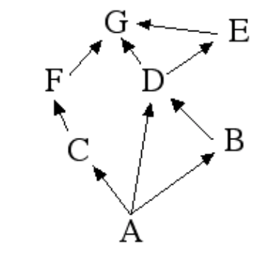
- Using the following food web, answer the following questions:
  - Which letter represents the producers?

  - Which letters could represent herbivores?

  - Which letter could represent an omnivore?

  - Which letter represents a potential population with the greatest biomass?

  - Which letter represents a top carnivore?

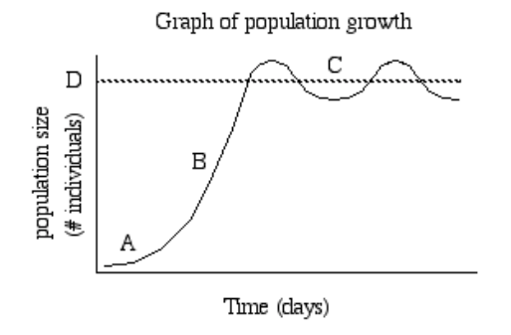
- Based on the graph of population growth, answer the following questions:
  - Which letter represents slow growth with few individuals?

  - Which letter(s) represents the carrying capacity?

  - Which letter represents exponential growth?

  - What type of growth is represented by the overall graph?

- Give an example for each of the following species roles or interactions:

Interaction | Example/Definition
Parasitism
Predator/Prey
Competition
Mutualism
Commensalism
Indicator Species
Keystone Species
Invasive Species
Native Species
Non-native Species

