Name __________________________________________ ES Unit 1 Sheet: Science Literacy

Students will handwrite answer to all vocabulary, study guide questions and additional study problems as outlined below. Supplemental and Reading Material provide additional information to help master concepts.

Essential Standards: | Students Will Be Able To:
2.1.2 Make Predictions Based on Data  2.1.2 Utilize Various Maps | - Make predictions based on data and observations  - Investigate natural phenomena using the scientific method  - Identify SI units and make accurate conversions in the metric system  - Accurately measure distance, mass, volume, and density – including mathematical calculations  - Utilize latitude and longitude coordinates  - Read and understand topographic maps

Vocabulary—Define, know, and be able to apply the following terms:

1. Hypothesis*
2. Theory
3. Independent Variable*
4. Dependent Variable*
5. Geosphere*
6. Hydrosphere*
7. Atmosphere*
8. Biosphere*
9. System*
10. Latitude*
11. Longitude*
12. Topography*
13. Contour Line*
14. Contour Interval
15. Gradient
16. Relief

Academic students complete vocabulary with asterisks * only. Honors students complete all 16 words.

Study Guide—Answer, know, and understand the following concepts:
- List & outline the steps of the scientific method.
- Contrast hypothesis and theory.
- Identify three safety measures taken in a laboratory setting and describe the importance of each.
- Describe the direction that parallels and meridians run and ways to utilize latitude and longitude.
- Identify at least two uses of topographic maps.
- List several components of each of the four earth systems.
- Identify several areas of scientific study under each of the four earth systems.
- Define a system and explain how the earth functions as a system.
- Identify the two major sources of energy for all the earth systems.
- Discuss the impact of humans on each of the four systems.

Supplemental--Practice the following activities as you work through the unit:
- Create a sketch that illustrates the following on a topographic map: hill, depression, steep slope, gradual slope, exact elevations.
- Measure distance, volume, and mass using SI.
- Convert measurements within the Metric System.
- Calculate volume mathematically.

Unit Reading Material:
- Hardcopy Textbook: Chapter 1 pages 7-9, 11-16, 18-22, 23-24, 728-733, 741-742
- Online Textbook: Ch. 2.1-2.3
- Class Notes and Handouts

Additional Study Problems:
- In the space provided, sketch a topographic map that would theoretically represent the following land form. Label the steep slope and the gradual slope.
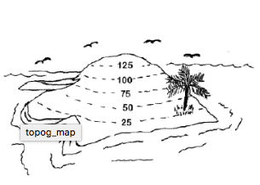
- Using the following topographic map, answer the following questions:
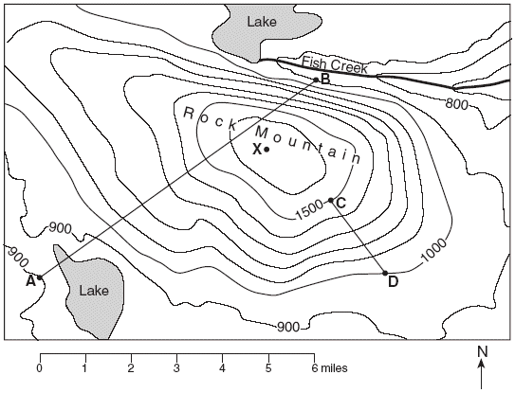
A. What direction would a person be traveling if they went from point A to point B?

B. What is the value of each contour interval?

C. A person travels from point C to point D, determine their total change in elevation.

- Read the following instruments correctly based on the specified units of measurement:
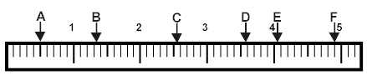

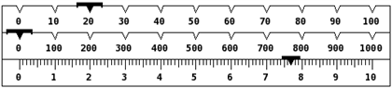
A ______ cm / _____ mm
C ______ cm / _____ mm

F ______ cm / _____ mm

_________ grams

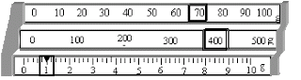
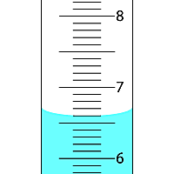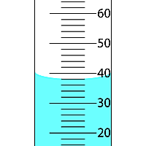
_________ grams
______ mL ______ mL

- Convert the following (show work using dimensional analysis):

  - 4.5 km = _________ m

  - 30.5 cg = _________ hg

  - 80 mL = __________ dcL

  - 4 days = __________ seconds

  - 11.16 cm = ________ inches

  - Bonus: 5670 mm = ________ feet

- Calculate the following (show all work):

  - A square piece of metal has sides that are 30 mm on each side. Determine the volume of the aluminum in cm³.

  - If the mass of the metal (in part a) is 47 grams, find the density of the metal.

  - What is the most likely identify of the metal based on the following table of metal densities?
Metal | Density (g/cm³)
Aluminum | 2.702
Copper | 8.92
Magnesium | 1.74
Titanium | 4.50

  - Bonus: A piece of an unknown metal weighs 0.9 kg. The metal was placed into a 200-mL graduated cylinder with 78 mL of water. The water level rose to 179 mL when the metal was place in. Determine the identity of the unknown metal. (Hint: Pay attention to units & use the table above to determine which metal it could be.)

