EXTRA PRACTICE: Unit 2 Name:__________________________ Date:____________ Pd:______

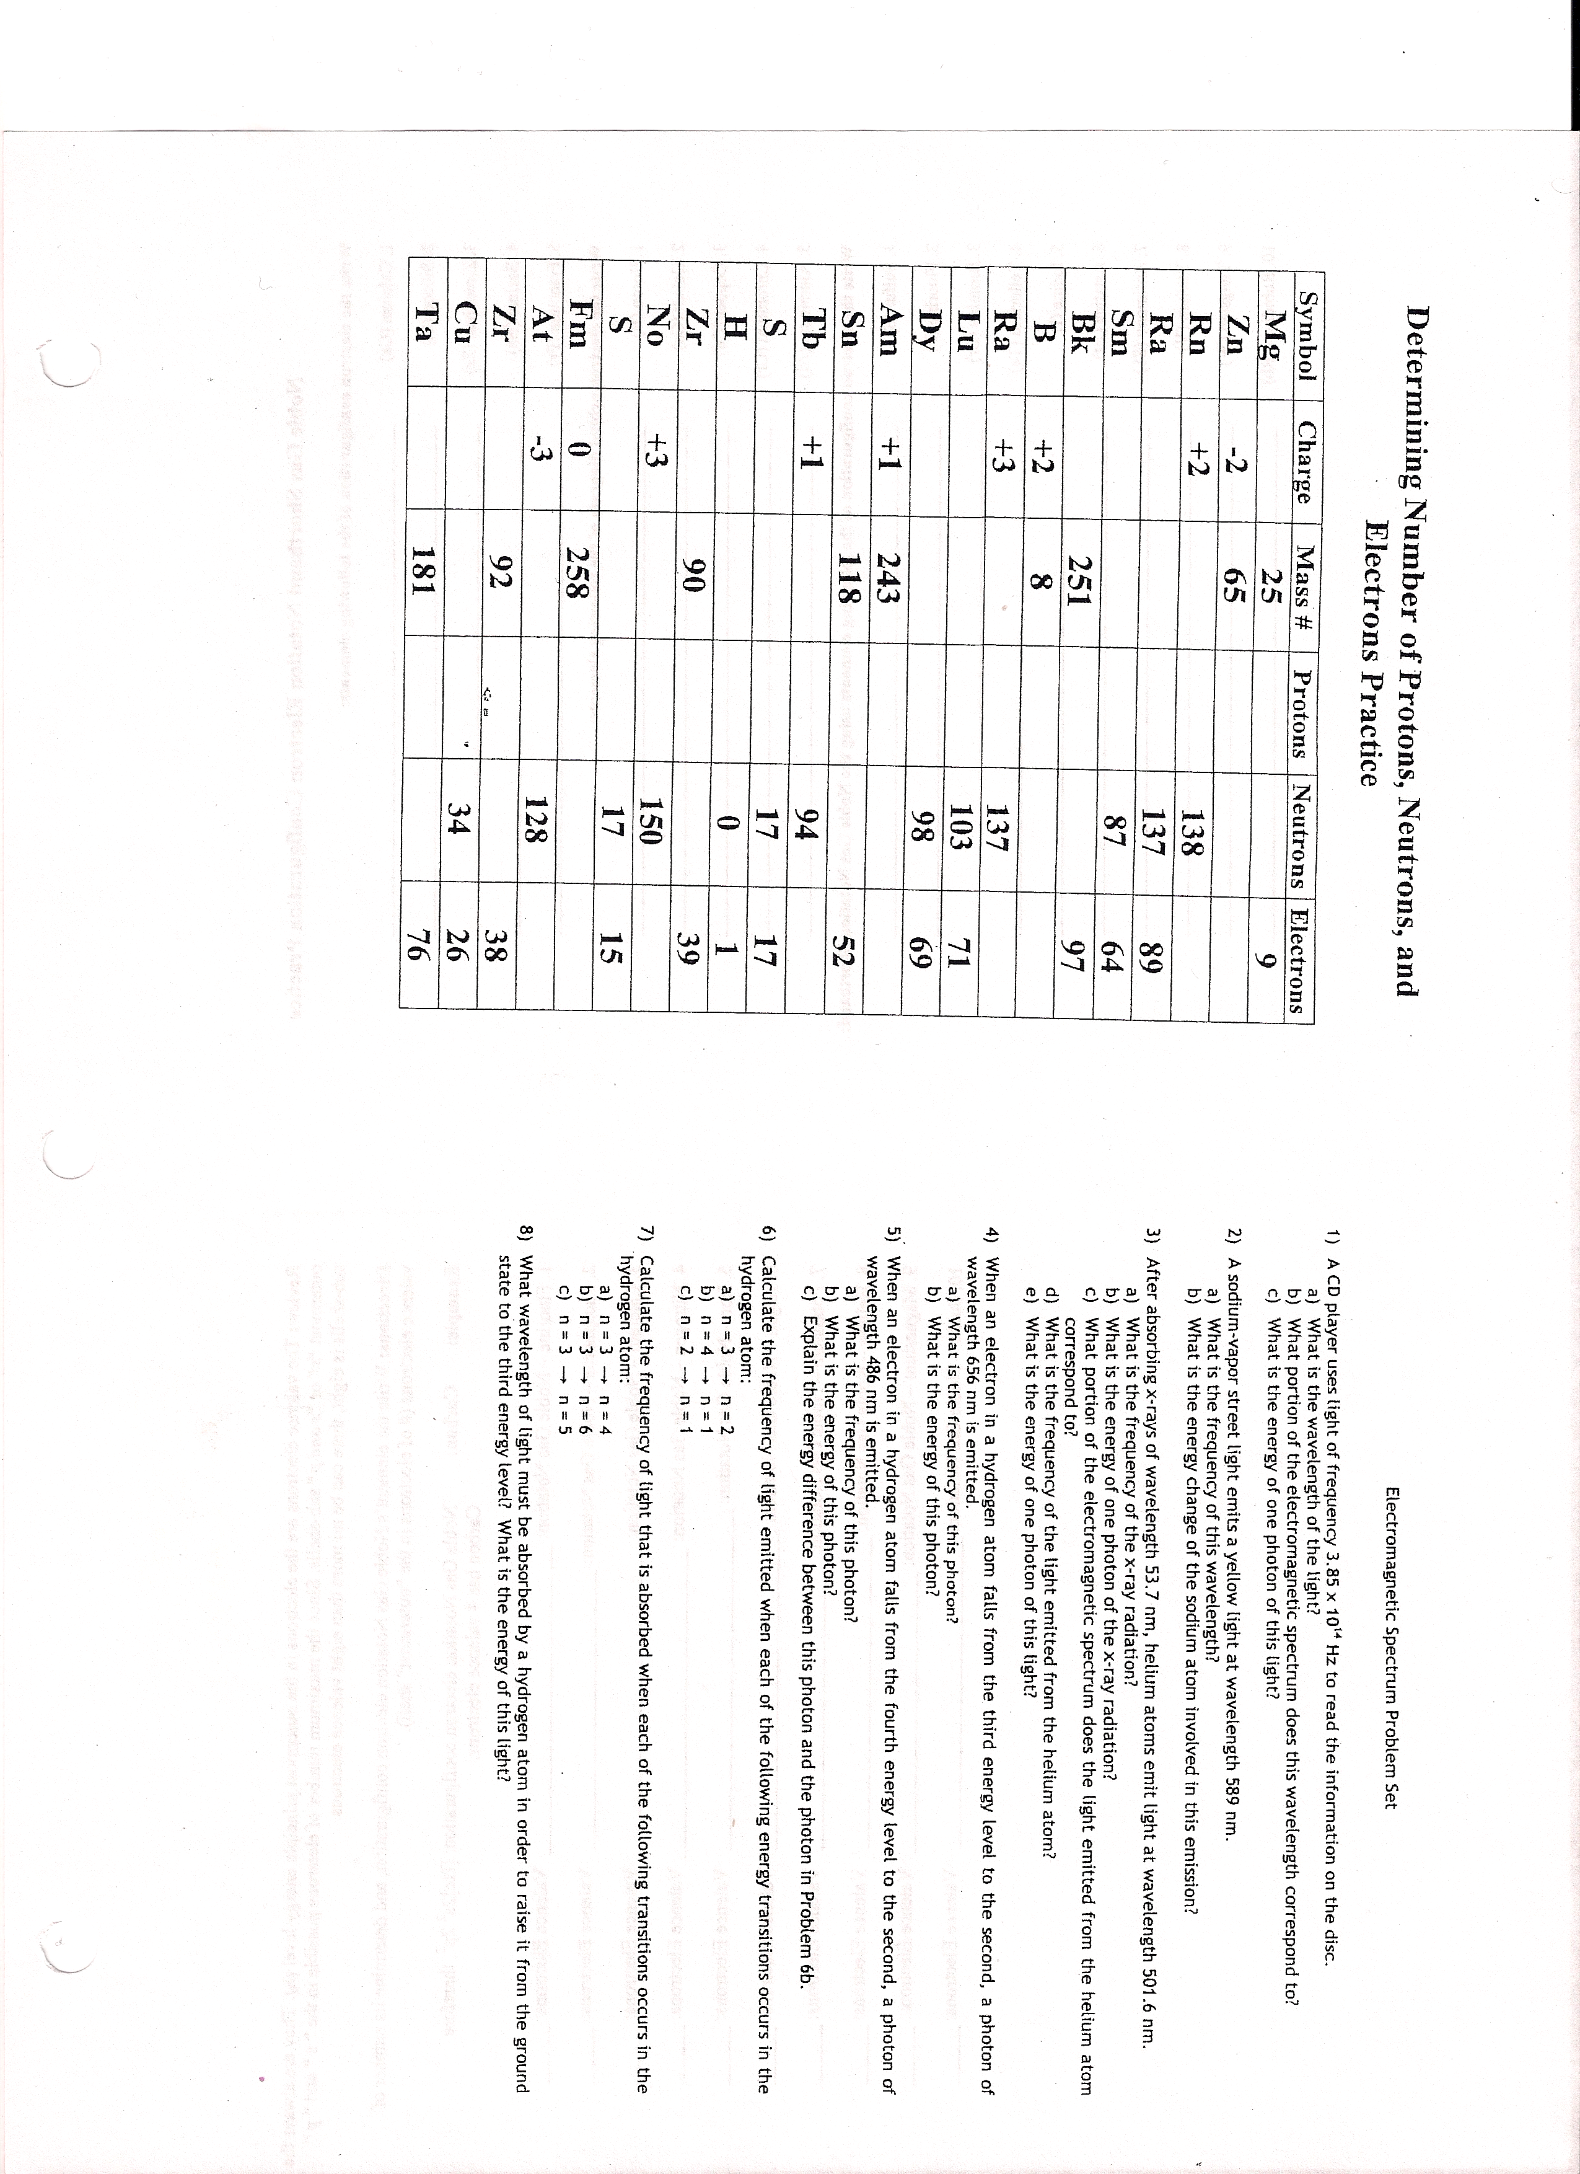

Write the electron configuration notation of the following elements:

1. Calcium (Ca) ____________________________________________________________________

2. Silicon (Si) ____________________________________________________________________

3. Zirconium (Zr) ____________________________________________________________________

4. Barium (Ba) ____________________________________________________________________

5. Francium (Fr) ____________________________________________________________________

Write the orbital notation (orbital diagram) of the following elements:

1. Boron (B) ____________________________________________________________________

2. Cobalt (Co) ____________________________________________________________________

3. Copper (Cu) ____________________________________________________________________

4. Chromium (Cr) ____________________________________________________________________

5. Aluminum (Al) ____________________________________________________________________

Write the noble gas notation of the following elements:

1. Sulfur (S) ____________________________________________________________________

2. Fluorine (F) ____________________________________________________________________

3. Bromine (Br) ____________________________________________________________________

4. Tellurium (Te) ____________________________________________________________________

5. Iodine (I) ____________________________________________________________________

6. Astatine (At) ____________________________________________________________________

7. Antimony (Sb) ____________________________________________________________________

8. Yttrium (Y) ____________________________________________________________________

9. Tungsten (W) ____________________________________________________________________

10. Rubidium (Rb) ____________________________________________________________________

Review: The valence electrons are the electrons in the outermost principle energy level (n). They are always the outermost “s” or “s and p” sub-shells. Since the maximum number of electrons possible in the “ s “ and “ p “ sub-shells is eight, there can be no more than eight valence electrons.

Directions: Write the element’s Noble Gas Notation electron configuration, and determine its number of valence electrons (# of electrons in the “outermost” shell).

Example: Carbon: Noble Gas Notation electron configuration: [He]2s² 2p², therefore
Carbon has 4 valence electrons.

1. Fluorine – Noble Gas Notation: __________________________________ Valence Electrons: ______
2. Phosphorus – Noble Gas Notation: ________________________________ Valence Electrons: ______
3. Calcium – Noble Gas Notation: __________________________________ Valence Electrons: ______
4. Nitrogen – Noble Gas Notation: __________________________________ Valence Electrons: ______
5. Iron – Noble Gas Notation: ______________________________________ Valence Electrons: ______
6. Argon – Noble Gas Notation: ____________________________________ Valence Electrons: ______
7. Potassium – Noble Gas Notation: _________________________________ Valence Electrons: ______
8. Helium – Noble Gas Notation: ___________________________________ Valence Electrons: ______
9. Magnesium – Noble Gas Notation: ________________________________ Valence Electrons: ______
10. Sulfur – Noble Gas Notation: ___________________________________ Valence Electrons: ______

