Name: Date: ________________ Pd: ________

PHASE DIAGRAMS #3
(Single Component)

Part A – Generic Phase Diagram
Answer the questions below in relation to the following generic phase diagram.
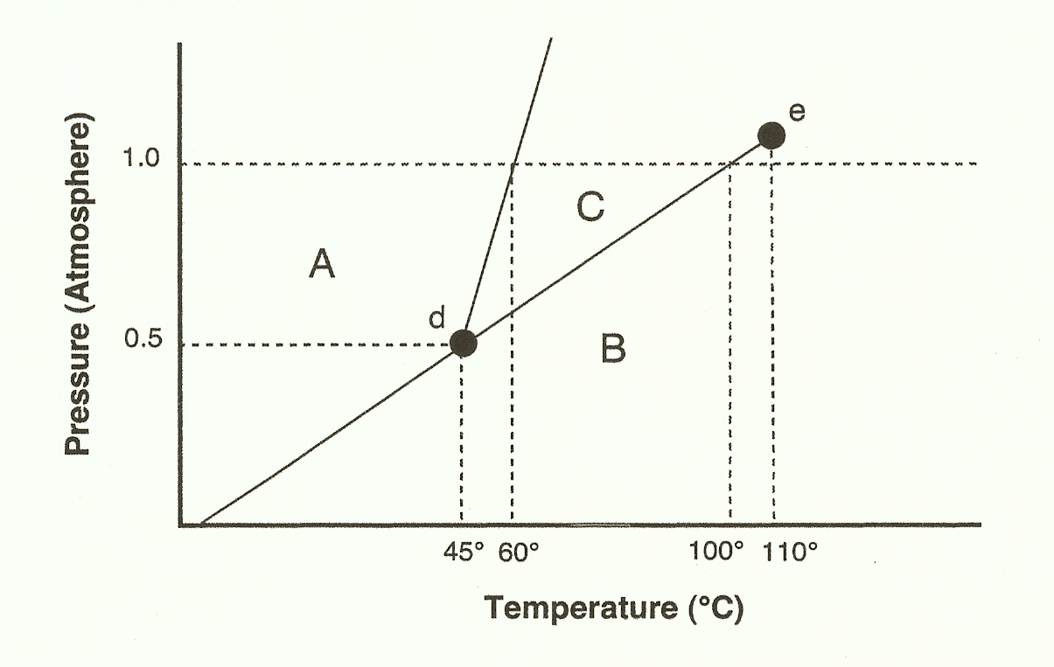

1. Which section represents the solid phase? ________
2. What section represents the liquid phase? ________
3. What section represents the gas phase? ________
4. What letter represents the triple point? ________
5. In your own words, what is the definition of a triple point?

6. What is this substance’s normal melting point? _________
7. What is this substance’s normal boiling point? _________
8. Above what temperature is it impossible to liquefy this substance, no matter what the pressure? _________
9. At what temperature and pressure do all three phases coexist? ___________________
10. At a constant temperature, what would you do to cause this substance to change from the liquid phase to the solid phase?
11. What does sublimation mean?
Part B – Phase Diagram for Water
12. What is the normal freezing point of water? ________
13. What is the normal boiling point of water? ________
14. In Albuquerque, NM, it is approximately 5,500 feet above sea level, which means the normal atmospheric pressure is less than 1 atm. In Albuquerque, will water freeze at a lower temperature or a higher temperature than at 1 atmosphere? ____________
15. If the normal atmospheric pressure is less than 1 atm, will water boil at a higher or lower temperature, than at 1 atmosphere? ____________
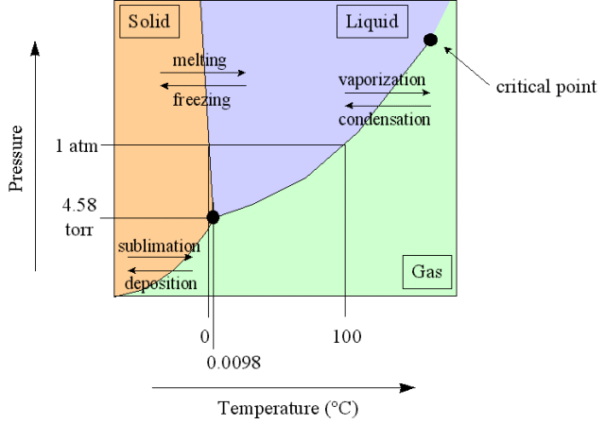

Part C – Phase Diagram for Carbon Dioxide

16. At 1 atmosphere and room temperature (25°C), would you expect solid carbon dioxide to melt to the liquid phase, or sublime to the gas phase? ________________
17. Some industrial processes require carbon dioxide. The carbon dioxide is stored on-site in large tanks as liquid carbon dioxide. Assuming we lived at sea level (1 atm), how could carbon dioxide be liquefied?
