Atmosphere Characteristics Practice Name: ________________________

MULTIPLE CHOICE: Circle the letter of the choice that best completes the statement.

- ________ Most of the Earth’s atmosphere is composed of _______________.
  - Oxygen and hydrogen c. nitrogen and oxygen
  - Hydrogen and nitrogen d. carbon and ozone
- ________ Water vapor in the atmosphere is the source of _______________.
  - Clouds and rain c. carbon dioxide
  - Pollution d. wind
- ________ The amount of energy the atmosphere absorbs depends in part on its level of ____________________.
  - Nitrogen c. nitrogen dioxide
  - Argon d. carbon dioxide
- ________ Solid particles in the atmosphere include salt and _______________.
  - Leaves c. dust
  - Ozone d. lightning
- ________ Ozone in Earth’s atmosphere is important because it _______________.
  - Causes rain to fall c. absorbs harmful pollution
  - Absorbs harmful radiation d. helps clouds form

COMPLETION: Complete the table by writing the name of the atmospheric layer that matches each description.

CHARACTERISTIC | ATMOSPHERIC LAYER
- Contains concentrated ozone
- Layer just above the stratosphere
- Most weather occurs here
- Outermost layer of the atmosphere
- Between mesosphere and exosphere

COMPLETION:
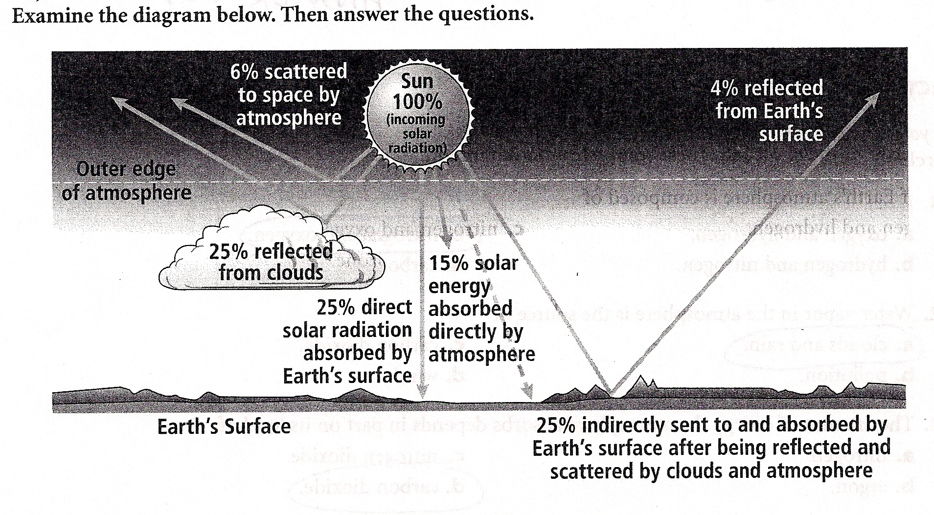
- What is the source of all energy that reaches the Earth? __________________________
- What percentage of the Sun’s energy does Earth’s surface absorb directly or indirectly? ________________
- What percentage of the Sun’s energy is scattered or reflected back into space? _________________
  - What causes this loss of solar energy? ______________________________________________________________
- Earth’s surface is heated by energy from the Sun. For the most part, the re-released energy from the surface heats up the atmosphere. Describe the method by which energy is transferred from Earth’s surface to the air above it.
- Describe the purpose of the ozone layer and how it affects Earth.



